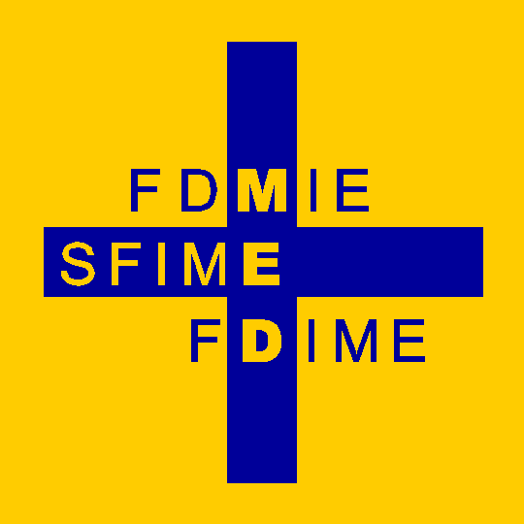 | Fondation pour le Développement de la Médecine Interne en Europe  Stiftung für die Förderung der Inneren Medizin in Europa  Foundation for the Development of Internal Medicine in Europe

June 2023
Attention: EFIM National Societies of Internal Medicine

Dear Friends and Colleagues

FDIME Announces the Availability of Research Grant in 2023

For Internal Medicine Research particularly polymorbidity & other I.M. conditions.

FDIME invites applications for Research Grant (up to 17,500 Euros). The aim is to promote research and to encourage exchanges within EFIM member countries. We need your help in circulating the Announcements to eligible young internists/researchers to encourage high quality applications to be submitted. Announcement and Application form is enclosed.

Young internists (up to the age of 38 years) from EFIM member countries are the target audience. The eligibility criteria must be met; as stated in the Announcements.

In order to promote European exchanges, we prefer the projects to be undertaken outside the YI’s country of residence as the funding is intended to support living expenses whilst the young researchers undertake their study project away from their home country. For the Internal Medicine research grant, the research can be undertaken locally, but collaboration with a French team of researchers is encouraged as the funding is provided by a French donor.
Applicants are required to submit their own Research Project proposal and identify a study location to carry out their research.

We ask you to advertise the Announcement to potential candidates via your National Society website, Newsletter, or by e-mail to your members. Text for your advertising media is enclosed.

With kind regards

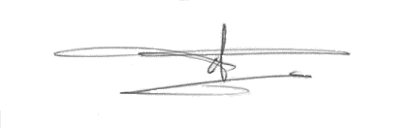
Pr Daniel Sereni
President, Foundation for the Development of Internal Medicine in Europe
e-mail: sereni.daniel@gmail.com

Encs : Announcement & Application form for Internal Medicine Research Grants
Text for your preferred advertising media

